May 2023
LHG/jr

Dear Parent/Guardian

Re: Summer Dance Showcase 2023

Your child is performing in the Summer Dance Showcase on Thursday 22 June 2023. The performance will take place at 7.00pm in The Berry Theatre.

A dress rehearsal will also take place on Thursday 22 June 2023 from 9.00am until 3.00pm in The Berry, please see the details below. Dancers must have their costumes for the dress rehearsal.

Period 1 – DanceLive! 2023
Period 2 – Year 7 Dance Club, Year 8 Dance Club
Period 3 – Junior Bare Roots, Year 9 dancers, The Unheard Boy’s Dance Company
Period 4 – Year 9 dancers, Year 10 dancers
Period 5 – Year 10 dancers, Senior Bare Roots

Dancers must arrive back at school in costume at 6.00pm.

Please note that tickets will be sold online at the following website:

https://thelittleboxoffice.com/wildernschool

Tickets are priced at £5.00 each and are available to purchase online from Monday 5 June 2023. Although the show is held in The Berry Theatre tickets must be purchased through The Little Box Office and will not be available through The Point Theatre or The Berry Theatre Box Office.

If you are unable to access the website, tickets can still be purchased by contacting the D@rt Centre on 01489 779471.

Tickets will be sold on a first come, first served basis, and have been known to sell out very quickly.

I look forward to seeing you at the performance, and if you have any questions please do not hesitate to contact me.

Yours faithfully
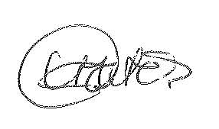

Mrs L Gates
Subject Leader – Dance

